12/10/2023

Brenda Beach & Jonathan Hardwick

Video Game Library & Sales

Video Game Library & Sales

User Manual

Contents

**Installation of Required Programs to Write Code** 1

**Installation of Python** 1

**Installation of Visual Studio Code** 7

**Download Website Code:** 15

1. Clone CSC289 GitHub Repository 15

2. Download Zip file 15

**Installation**: 16

# **Installation of Required Programs to Write Code**

Currently, the Video Game Library and Sales program is not set to be run by an executable, so you will need to download and install a couple of programs if you do not already have them. Those programs are Python and Visual Studio Code. You can use a different IDE other than Visual Studio Code, but for this installation manual, we will be using Visual Studio Code.

## **Installation of Python**

1. The first thing you need to do to install Python onto your system is to go to the website <https://www.python.org>.

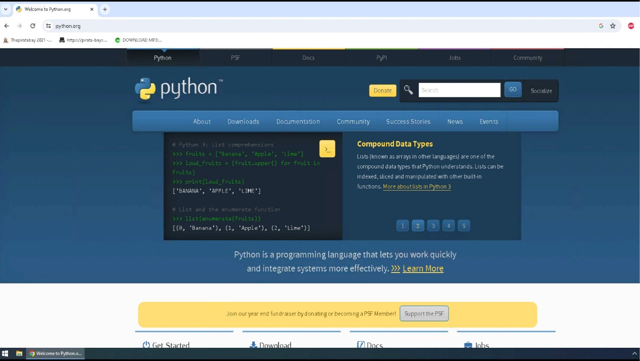

1. Once you have arrived at the website, you will click on the Downloads link and then click on the link to download the latest version of Python onto your system.

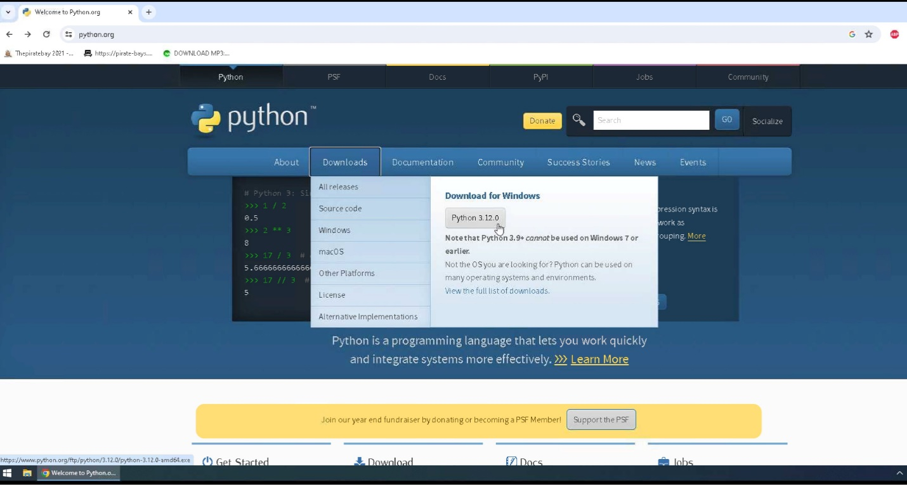

1. Python will download to your default downloads folder, and once it has been completed, you can click on the icon to view your downloaded file names in the upper right corner of your webpage so you can click on that file name and install the program onto your system.

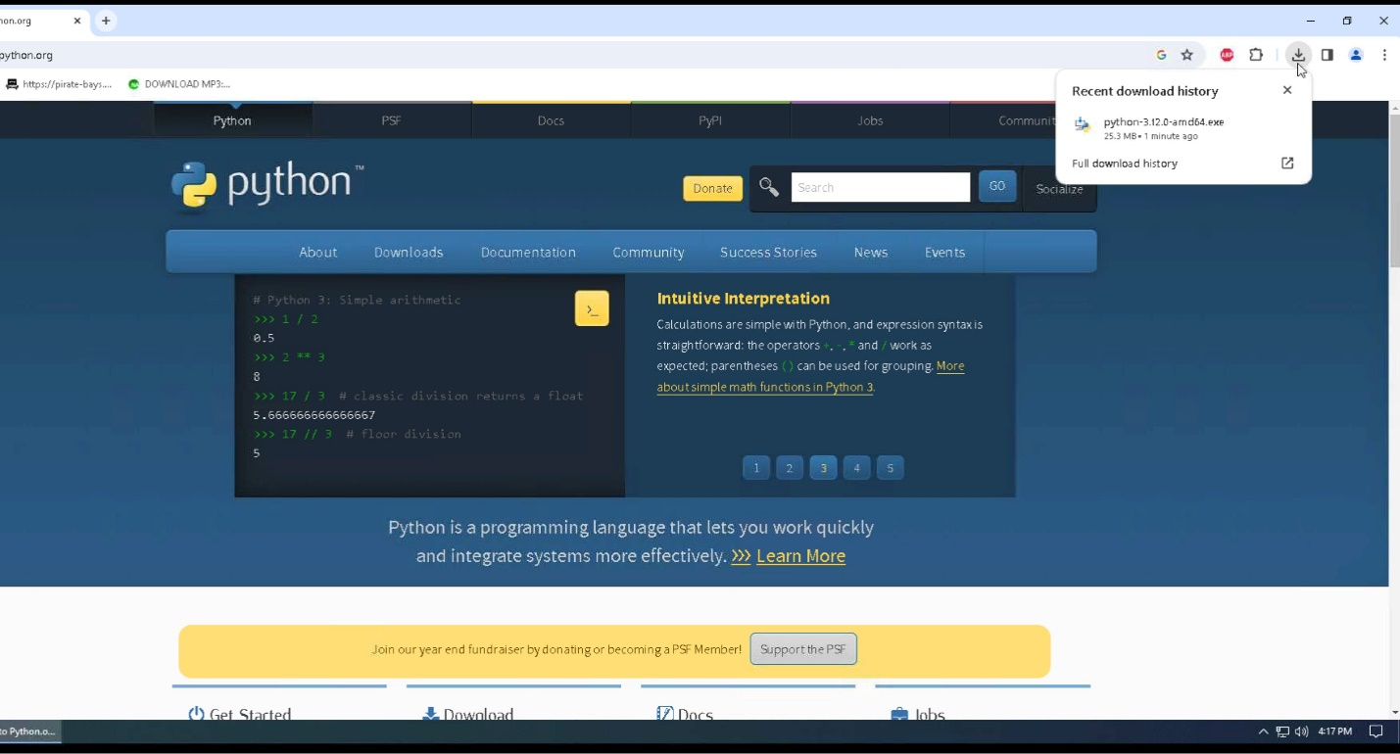

1. Click on run to install Python onto your system.

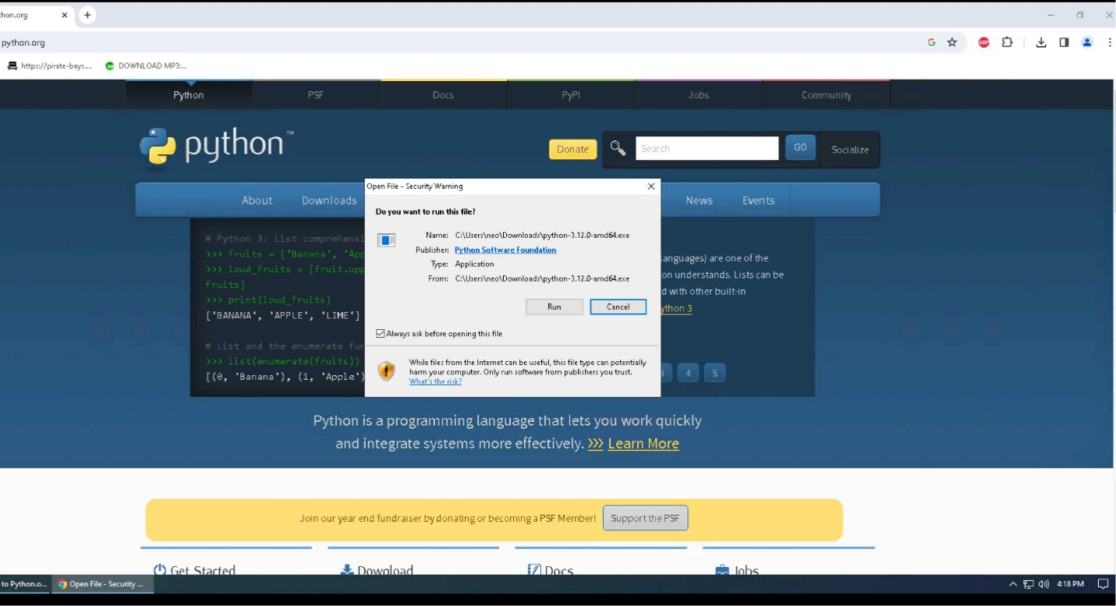

1. Click “Add Python to PATH,” then click Install Now.

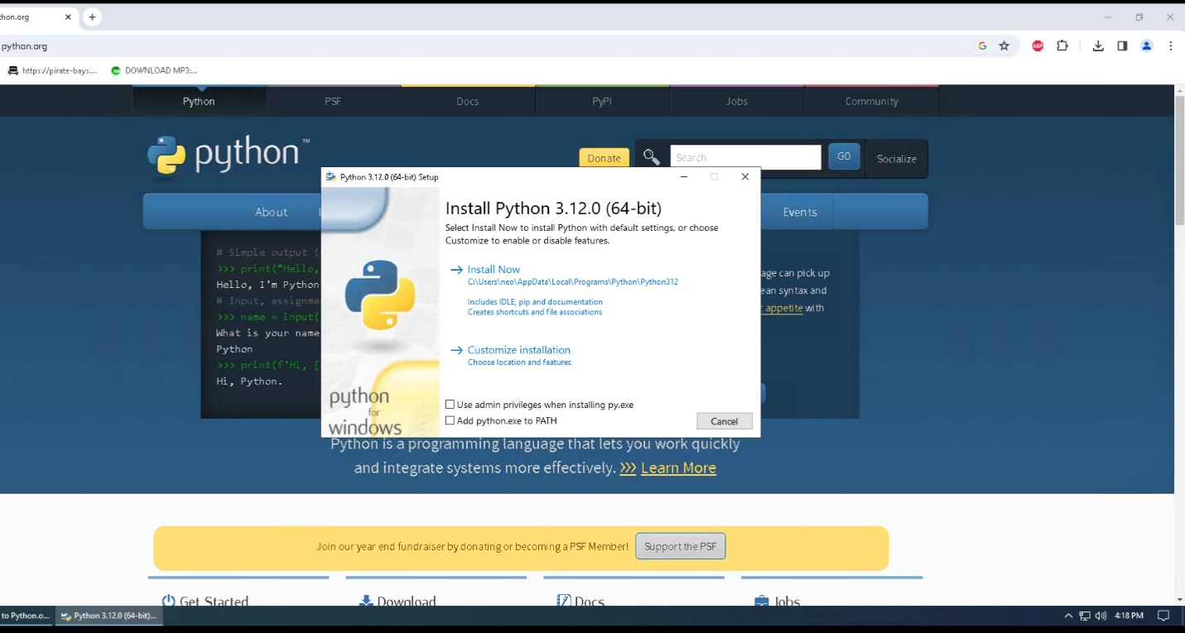

1. The program will now be installed on your system, and the status bar will show the progress level of the installation.

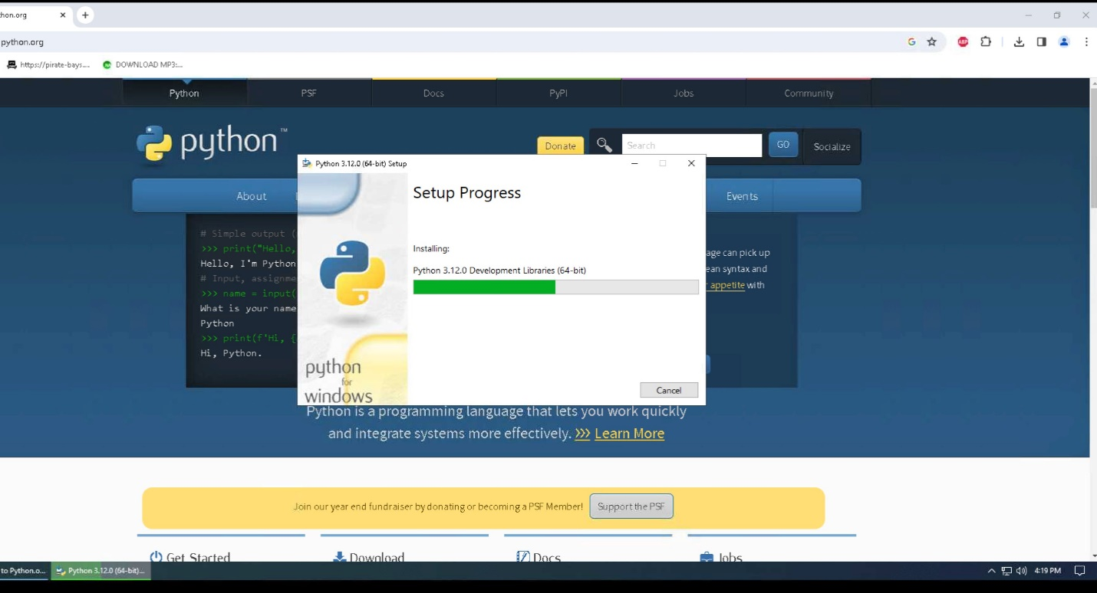

1. Once the installation is finished, click on “Close” to close the setup window. You can then close the web browser.

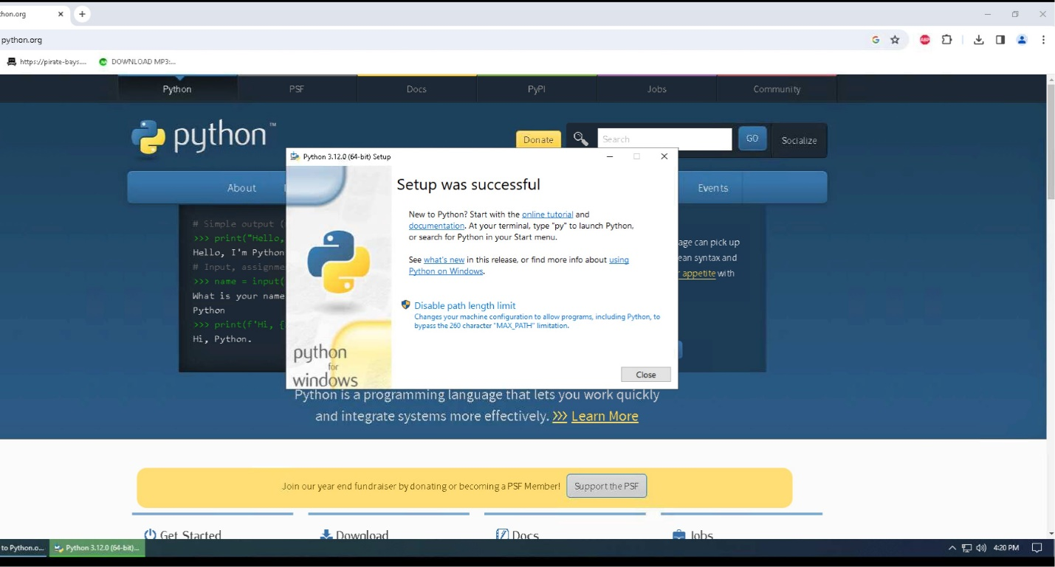

1. To verify the installation of Python onto your system, you can click on the Windows icon , also known as your start button, and under the recently added programs, you should see the Python program.

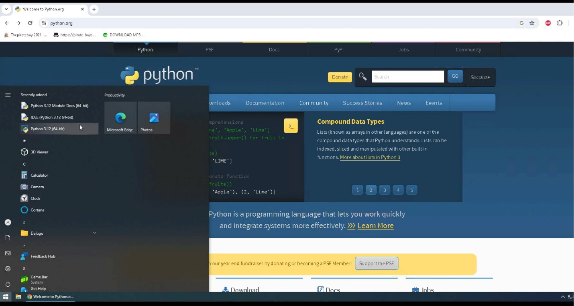

1. You can also verify that Python installed on your system by opening a command prompt (press the windows key and type cmd and select command prompt), and typing python –version. If you get an error message when you run this command, you must repeat these steps to reinstall Python on your system.

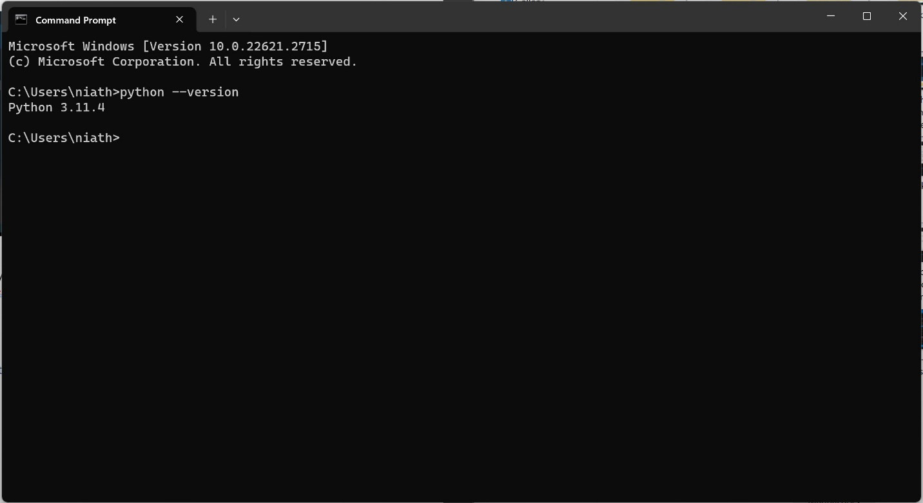

1. Now that Python is installed on your system, it is time to install our IDE so we can view our code and run the program.

## **Installation of Visual Studio Code**

1. To install Visual Studio Code, go to the webpage <https://code.visualstudio.com>.

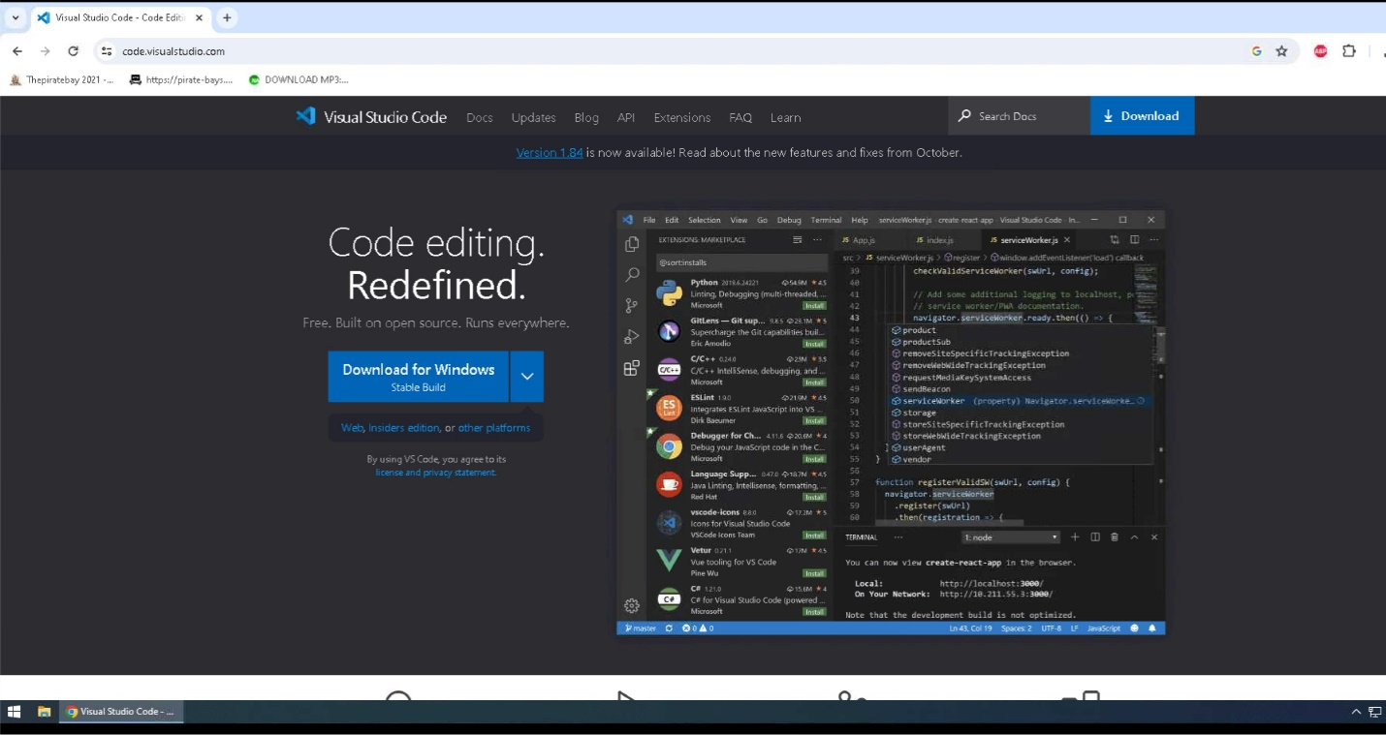

1. Click on download to download to your default downloads folder, and once it has been completed, you can click on the icon to view your downloaded file names in the upper right corner of your webpage.

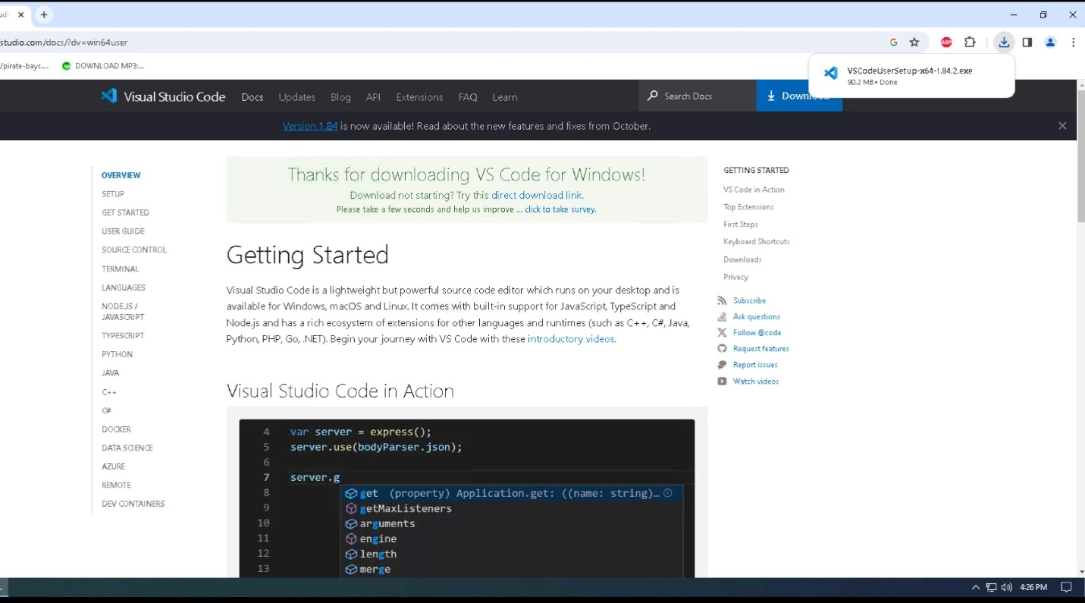

1. Click on the file name to install Visual Studio Code on your system.

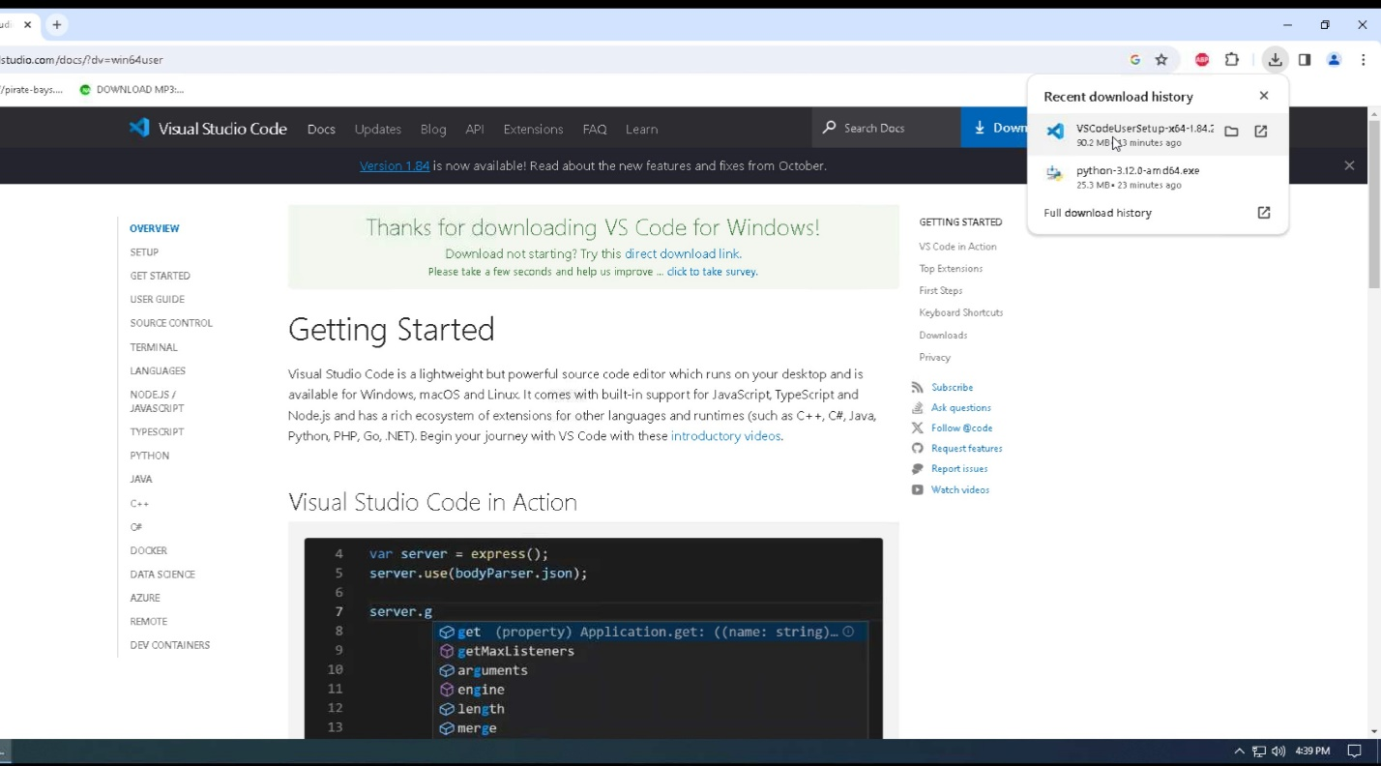

1. Click on “Run” to begin the installation of Visual Studio Code.

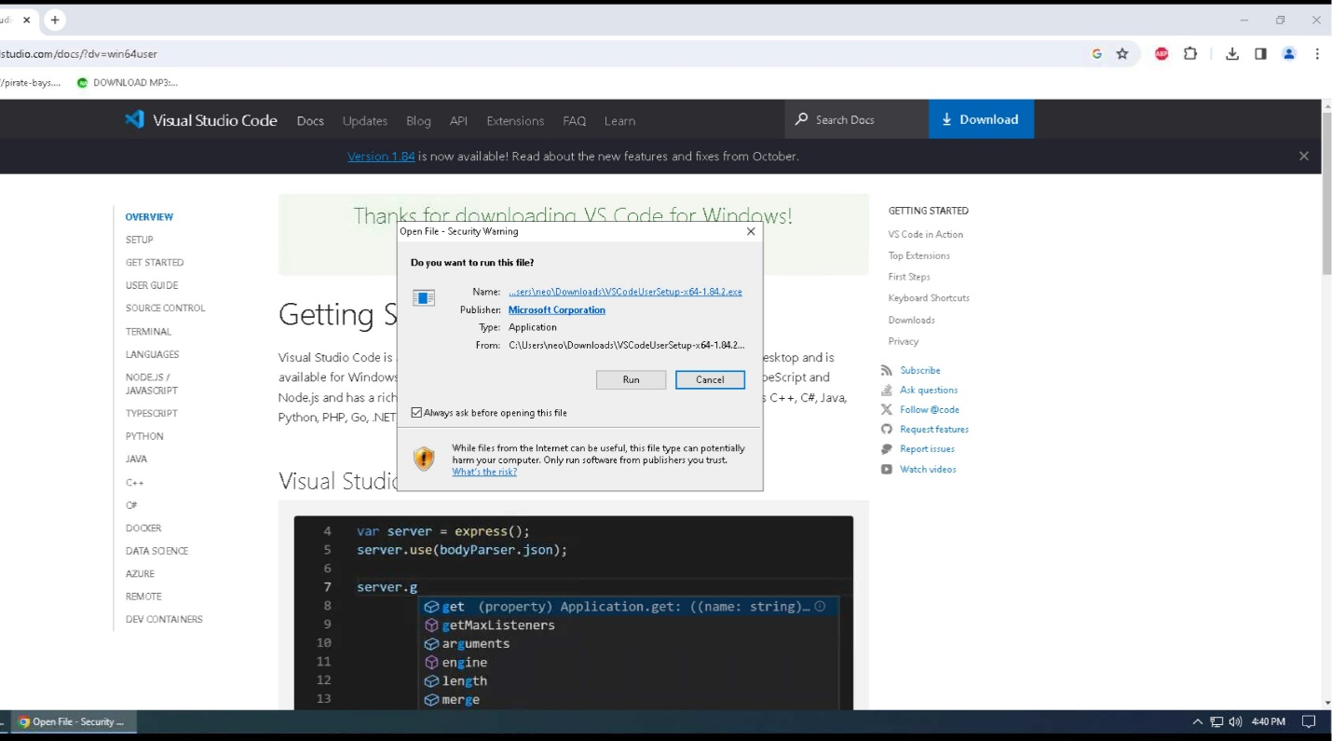

1. Select “I accept the agreement”, then click on Next.

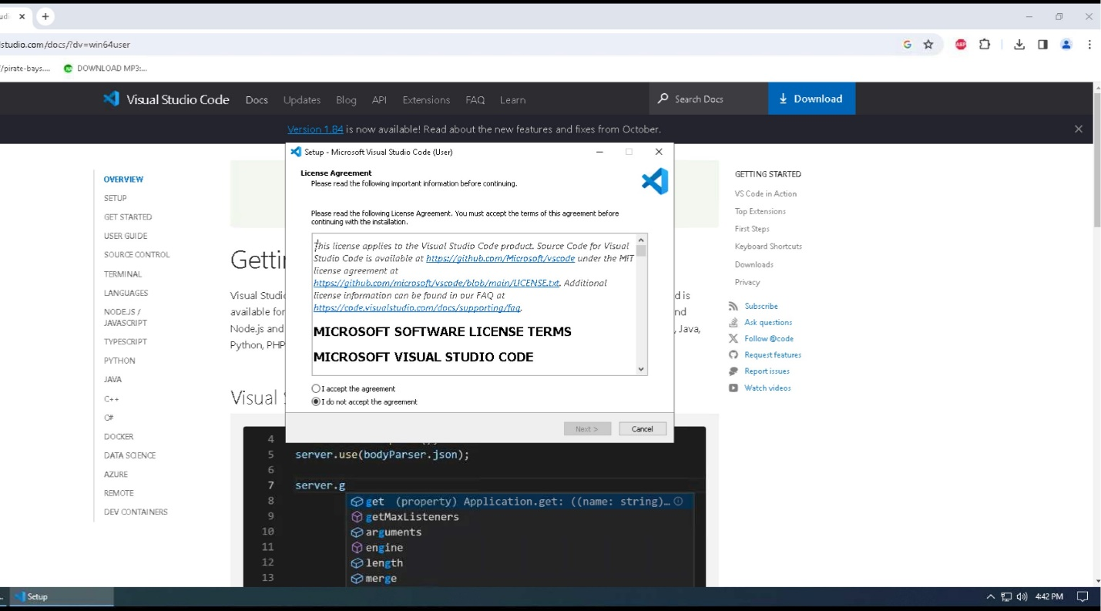

1. Click “Browse…” to select the location to install the program or leave it as the default location. Click Next to continue.

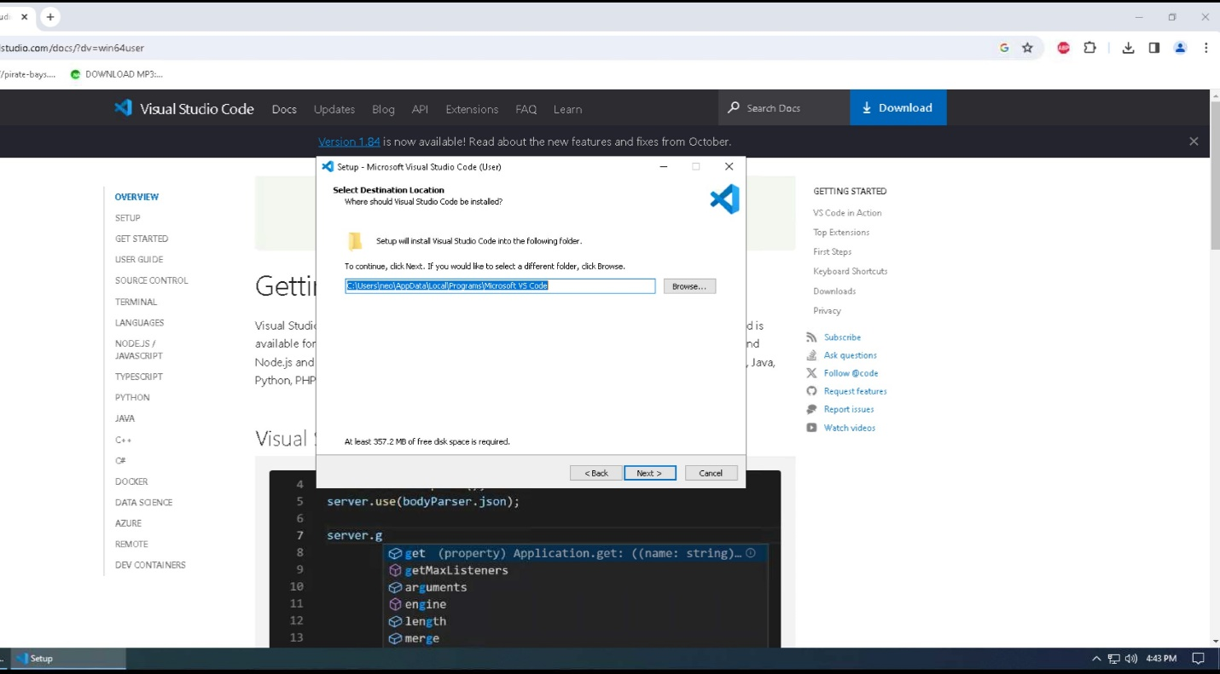

1. Click “Next” to accept the default location and continue to the next step in the installation process.

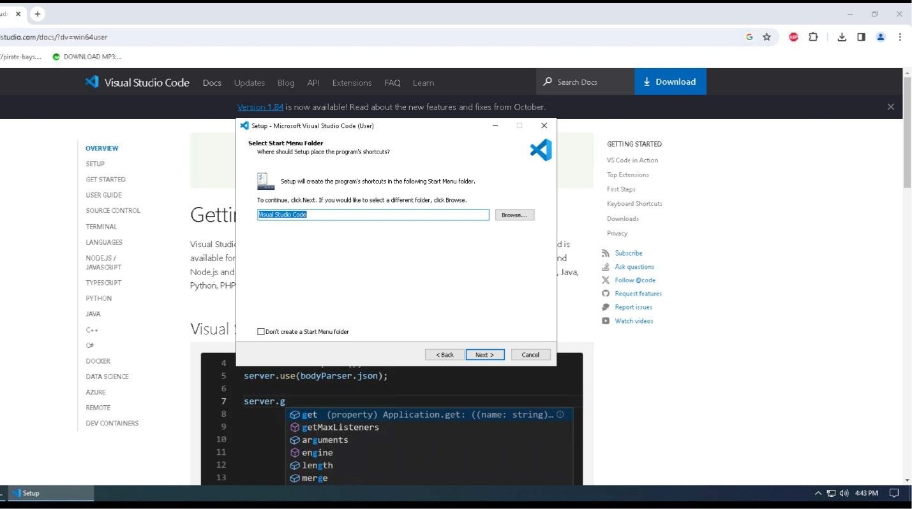

1. Click “Create Desktop Icon”, then click “Next” to continue to the next step of the installation process.

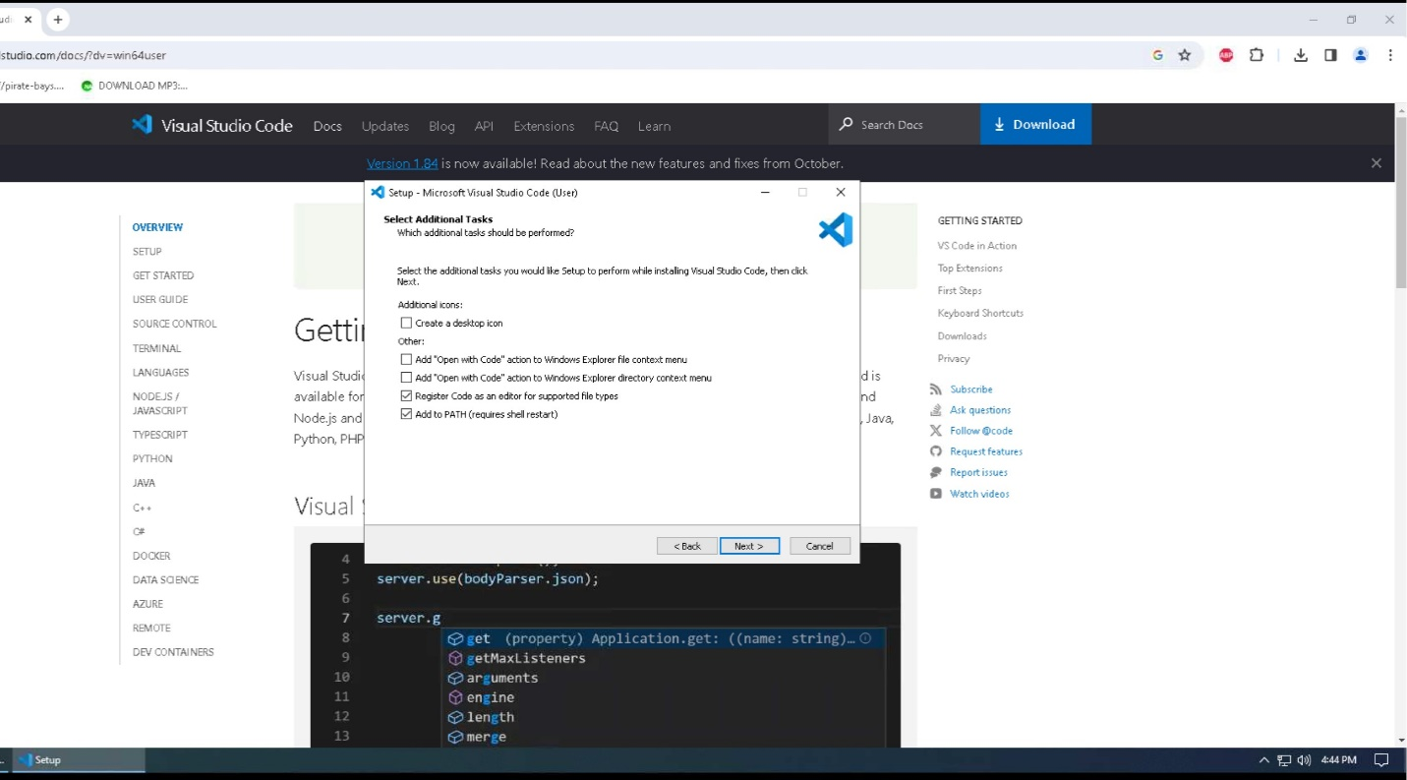

1. Click “Install” to install Visual Studio Code onto your system.

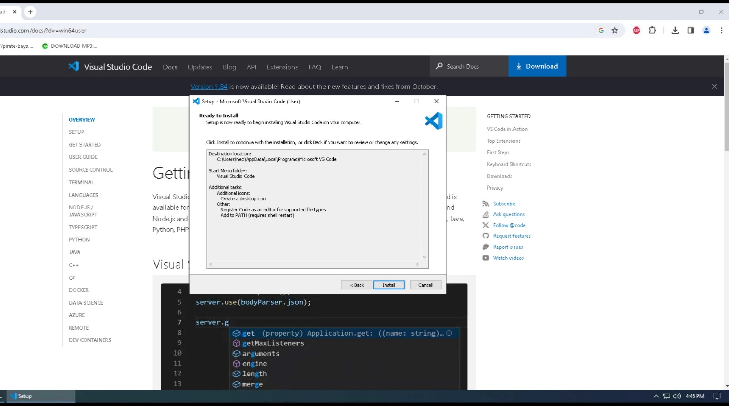

1. Visual Studio Code will now be installed on your system, and the status bar will show you the progress of that installation.

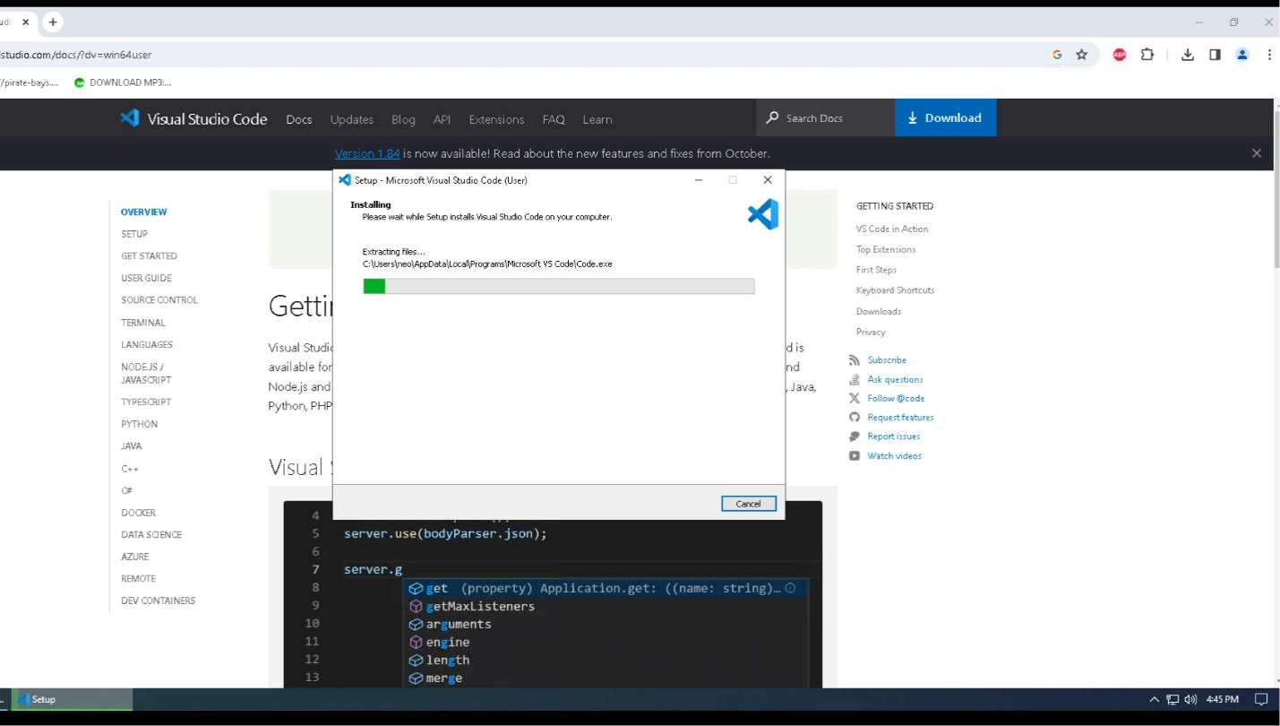

1. Once the program has been installed, ensure that “Launch Visual Studio Code” is checked before you click “Finish”. This will close out the installation window and start the Visual Studio Code program. You can also go ahead and close the web browser.

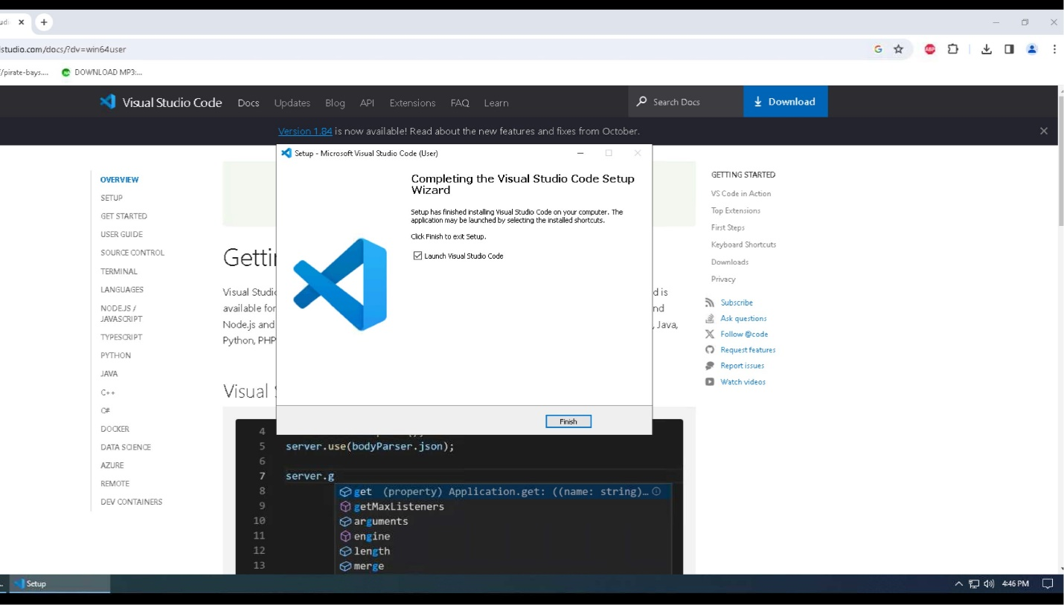

1. Visual Studio Code will now open. You will need to click on the "Extensions” icon 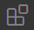 so the Python extension can be installed and write our Python code inside Visual Studio Code.

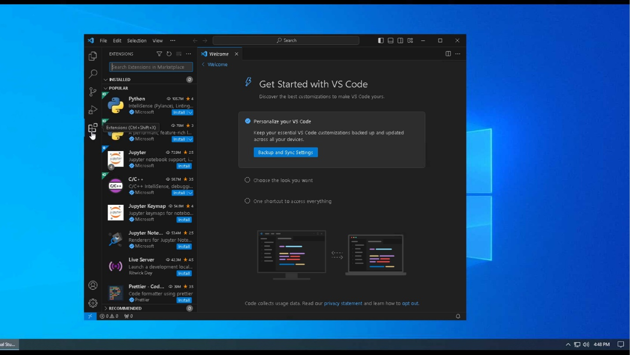

1. Click on “Install” under the Python Extension.

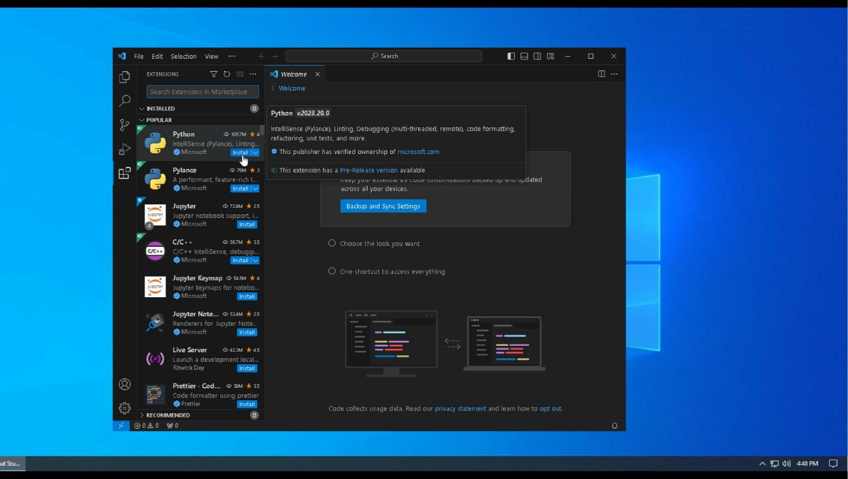

1. It will then install the Python extension. Once it is finished, you can write your Python code without receiving any errors.

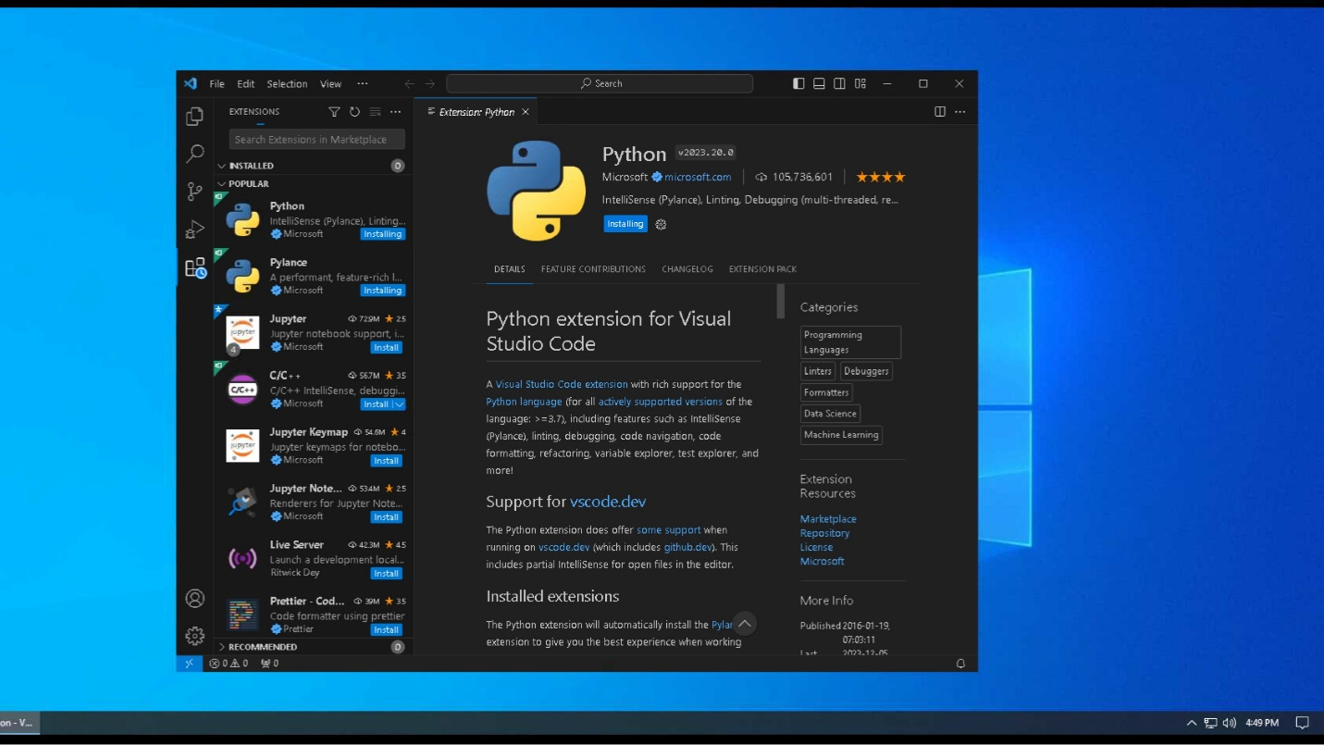

## **Download Website Code:**

You only need to choose one of the following methods to download the code.

### Clone CSC289 GitHub Repository

* 1. Install Github Desktop
     1. First go to desktop.github.com to download github desktop. Click the “Download for Windows” button. This will be downloaded to the downloads folder.

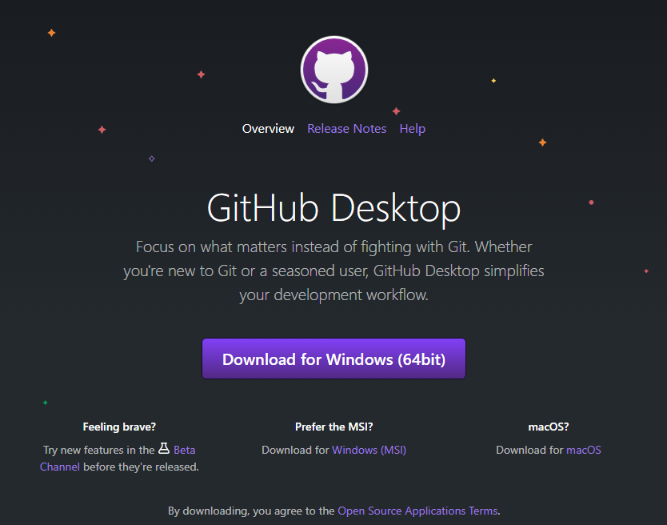

* + 1. Select the downloads icon in you browser.
    2. Click on GithubDesktopSetup-x64 to start the installation process.
  1. Clone the Github repo CSC289 to an empty folder on your computer
     1. Github repository (<https://github.com/MrChiff/CSC289>)

### Download Zip file

* 1. Visit <https://github.com/MrChiff/CSC289>, in your browser.
     1. Click the green “<> Code” button and select download zip from the drop down menu. This will download the zip file to the downloads folder.

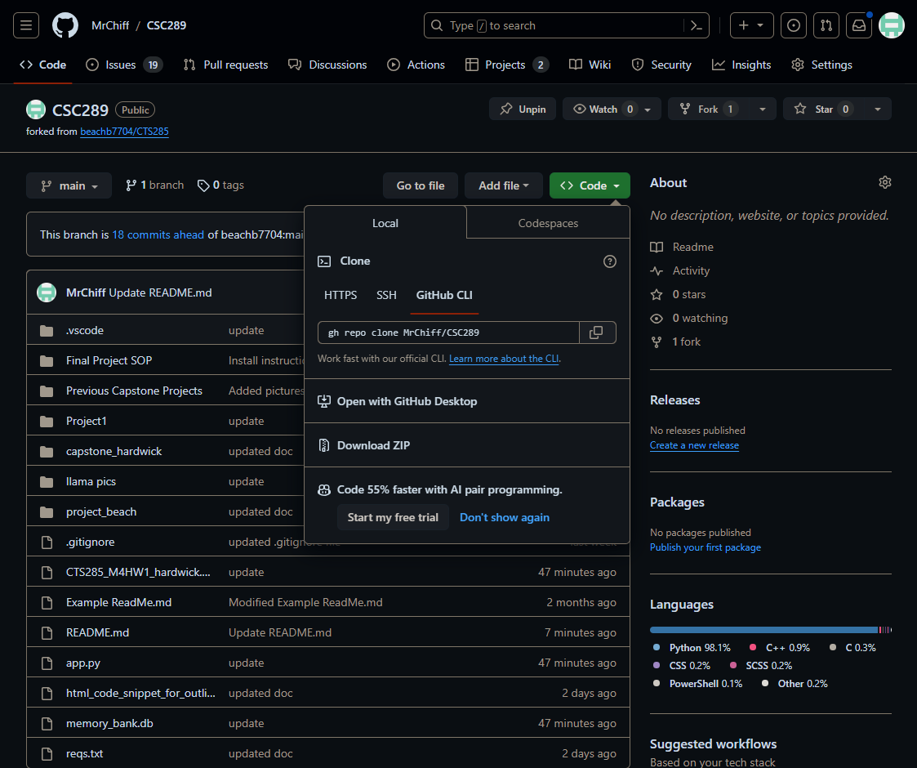

* + 1. Unzip the file.

## **Installation**:

1. Open command prompt on windows. (press the windows key and type cmd and select command prompt)
2. In the Command Prompt window,
   1. Navigate to the new folder.
      1. Use the command: cd “path to new folder”
   2. Create a Python virtual environment.
      1. Use the command: python -m virtualenv “your env name”
   3. Activate the virtual environment.
      1. Use the command: .\”your env name”\Scripts\activate
   4. Install the necessary modules.
      1. Use the command: pip install -r reqs.text
   5. Uninstall werkzeug.
      1. Use the command: pip uninstall werkzeug
      2. Enter Y to uninstall the module.
   6. Install werkzeug v2.3.7.
      1. Use the command: pip install werkzeug==2.3.7
   7. Change directory to the project folder.
      1. Use the command: cd project_beach
   8. Initialize the website.
      1. Use the command: python run.py
3. Go to the website <http://127.0.0.1:5000> in your web browser
4. Congratulations! You have launched the Video Game Library and Sales (VGLS) website.

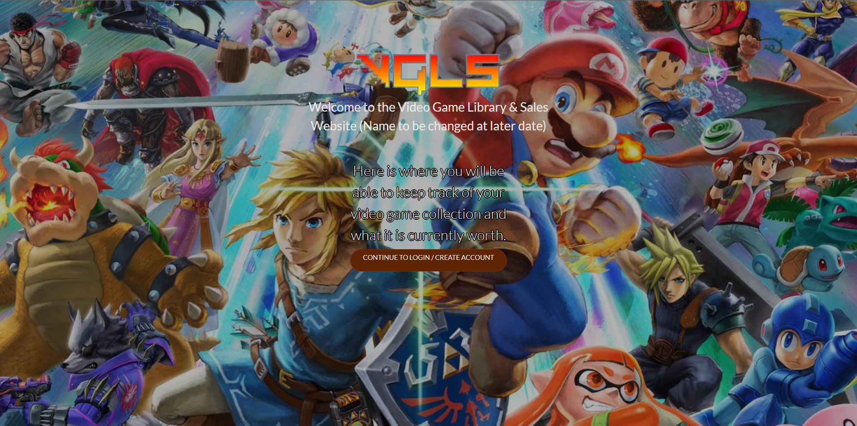

## Using the Website:

### View/Search for video games without logging in.

* 1. The website if fully searchable for users that do not have an account.
  2. An account allows the user to create a video game/console/accessory library and add items to this library.



(placeholder)

### Registration

* 1. In order to create an account click “Create Account” button
  2. Choose a username and password, and enter these items into the webpage.

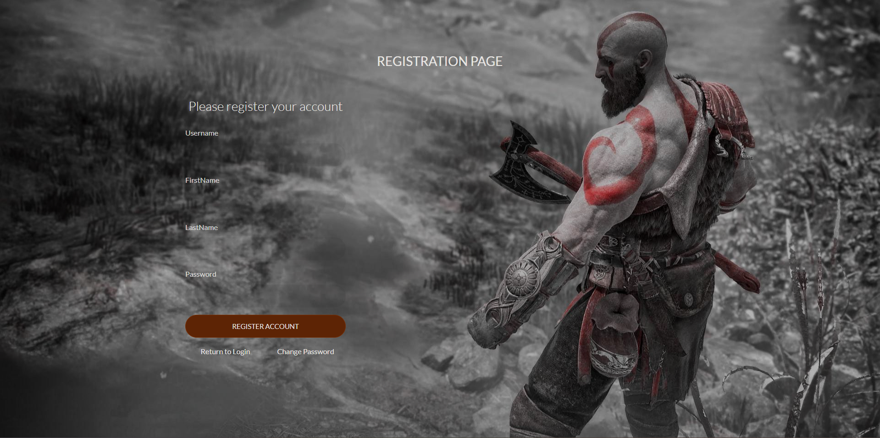

(placeholder)

### Login

* 1. Navigate to the login screen (explain this after have test site available)
  2. Enter your username and password into the appropriate boxes.

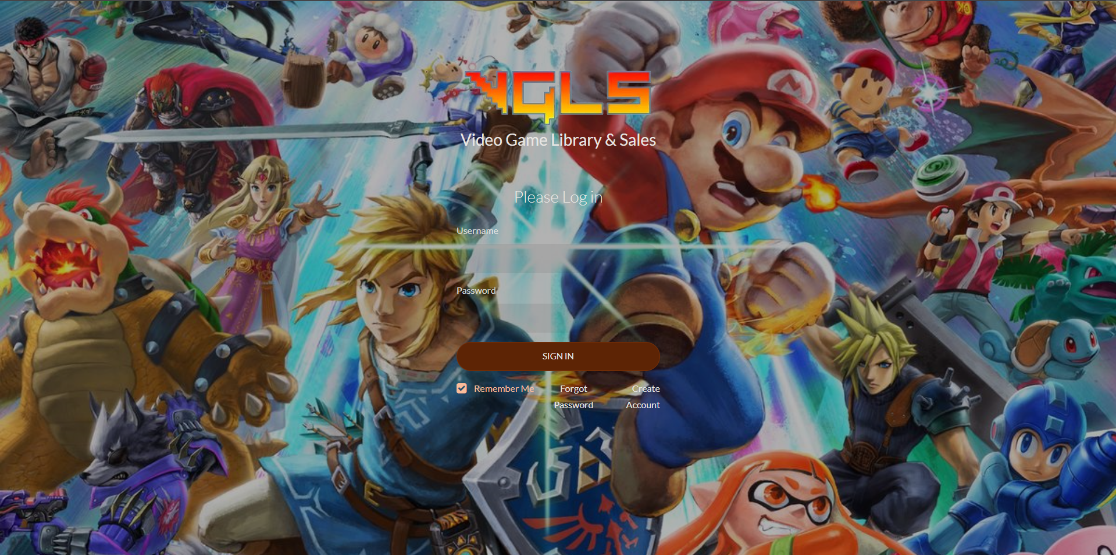

(placeholder)



### Change Password

* 1. Choose “User Settings” then choose the “Change Password”
  2. Enter username and new password.

Change Password Page

(placeholder)

### Reset password

* 1. If you have forgotten your password you and reset the password.
  2. Click on “CONTINUE TO LOGIN/CREATE ACCOUNT”
  3. Click on “Forgot Password”

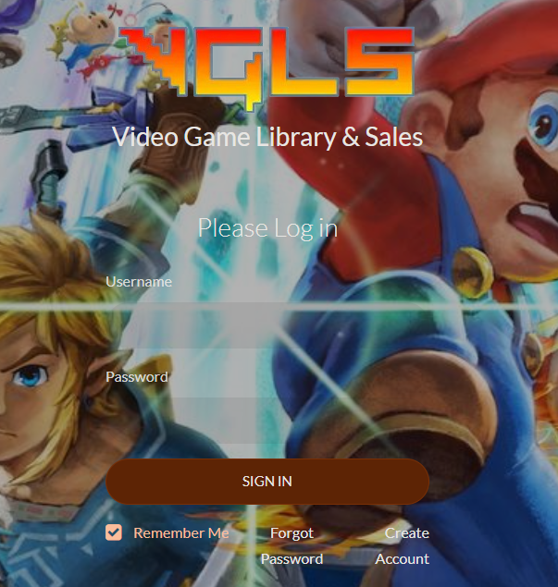

* 1. Enter username and new password

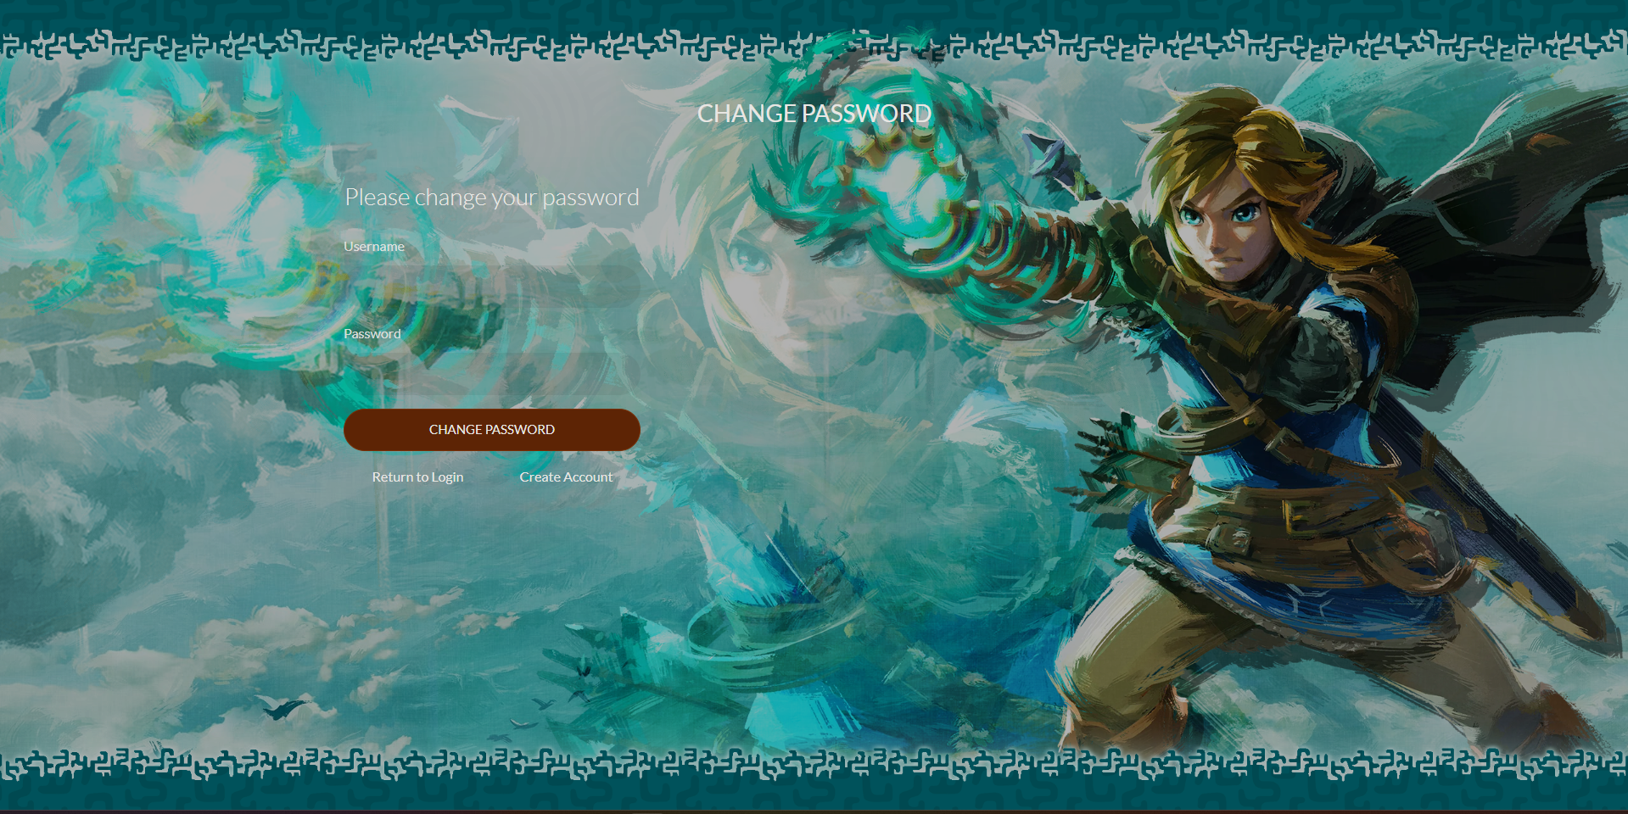

### Select/search for specific video game.

* 1. Click into the search box and type the desired video game/console/accessory

Search Page

* 1. Use the buttons to select the desired category. (video games/console/accessories)

Primary Category Page

(placeholder)

Secondary Category Page

(placeholder)

### Choose from the alphabetized list of games/consoles/accessories to find the desired item.

List of Specific Items Page

(placeholder)

### Select video game

List of Specific Items Page

(placeholder)

### Add video game to list connected to account

* 1. Only one of each item can be added to the library.
  2. To view the your library select the “Library” button in the navbar at the top of the page.

Library Page

(placeholder)

### Admin portal

* 1. Reset user’s password.
  2. View/edit databases

Admin Portal